Prerequisite: Fundamentals of testing and Python programming

Stage 1 - Robot Framework (Standard libraries - Builtin, String, Collections, Datetime)
Stage 2 - Robot Framework (External libraries for automation - Selenium (Web UI), Request Library (API), FlaUI (Desktop automation), Appium (Android, iOS, Windows))
Stage 3 - Customized Framework (Data Driven Framework, Keyword Driven Framework, Page Object Model, Config)
Stage 4 - Git & Jenkins (only if time permits)
Stage 5 - GitHub Copilot - Gen AI

Break 1 - 11:15 AM IST
Lunch - 1 to 2 PM
Break 2 - 3:30 PM

Python and Robot Framework
- Installation
  - Python
  - Add the python.exe folder and script folder to the environment PATH variable
C:\Program Files\Python314
C:\Program Files\Python314\Scripts
  - VS Code
    - Extension
      - Python
      - RobotCode

  - Pycharm
    - Extension
      - Robotcode
  - Libraries - Based on requirement
    - pip install robotframework

- Python Architecture
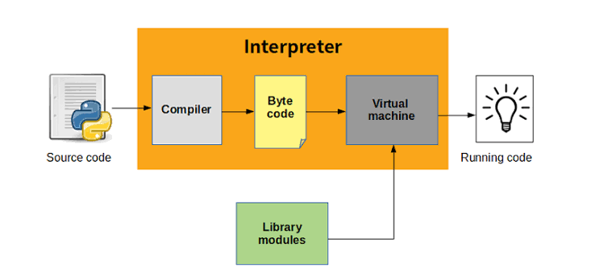
- Create Python Project
  - Create package
    - Create Python module (.py)
- To activate virtual env in pycharm/vs code terminal
.\.venv\Scripts\activate.ps1

- Python datatypes
  - Numeric - int, float
  - Sequence - String, List, Tuple
  - Dictionary
  - Boolean
- Methods - building block of the program
  - Reuse
  - Maintenance
Understand -
- how to create methods in a module (.py)
- How to call methods in a module (.py)

Robot Framework
- Setup of Robot Framework
Use (.venv)
pip install robotframework
- Standard libraries
  - Builtin
  - DateTime
  - String
  - Collections
- Sections
  - Settings
  - TestCases
  - Keywords
  - Variables
- Variable
  - Scalar ($)
  - List (@)
  - Dictionary (&)

SELENIUM LIBRARY
- Selenium Library install -
pip install --upgrade robotframework-seleniumlibrary
- Keyword doc - https://robotframework.org/SeleniumLibrary/SeleniumLibrary.html
- Selenium Architecture (WebDriver)

Source code (Python+WebDriver library) → driver → browser

- Click, type, select
- To inspect → tag name, attribute, text
- Basic locators
  - id
  - Name
  - Tagname
  - Classname
  - Linktext
  - Partial link text
When there are duplicate locators, selenium will pick the first locators

- Advance Locator
  - XPath
  - CSS
- For page load - wait for page load to complete
- All locators - should be present within 0.5s (500ms)
- Click - the element should be present and visible
- Dropdown
  - With select tag
    - Select From List By Label
    - Select From List By Value
    - Select From List By Index
  - Without select tag
- Synchronization
  - Unconditional wait (Built-in library) (not recommended)
    - Sleep 5s → not recommended (wait always for 5s)
  - Conditional wait (Selenium library)
    - Implicit wait
      - Default implicit wait - 0s
      - Applicable for all find_element (Get WebElement) and find_elements (Get WebElements)
      - Example: Implicit wait - 30s
        - If the element is not present, it will check for 30s and then throw an exception
        - If the element is present, it will proceed with the operation immediately
        - Polling time - 0.5s (how frequently it checks for element)
    - Explicit wait
      - Exact conditions

Strategy | Match based on | Example
id | Element id. | id:example
name | name attribute. | name:example
identifier | Either id or name. | identifier:example
class | Element class. | class:example
tag | Tag name. | tag:div
xpath | XPath expression. | xpath://div[@id="example"]
css | CSS selector. | css:div#example
dom | DOM expression. | dom:document.images[5]
link | Exact text a link has. | link:The example
partial link | Partial link text. | partial link:he ex
sizzle | Sizzle selector deprecated. | sizzle:div.example
data | Element data-* attribute | data:id:my_id
jquery | jQuery expression. | jquery:div.example
default | Keyword specific default behavior. | default:example

Exceptions:
- No locator found -
- ElementClickIntercepted → some popup hides the target element

Day 1

Task 1
1. Navigate onto https://www.medibuddy.in/
2. Close if any popup and Click on Login
3. Click on I have Corporate Account
4. Click on Learn More
5. Click on Skip
6. Click on Login using Username & Password
7. Enter username as john
8. Enter password as john123
9. Click on show password
10. Click log in
11. Get the error message shown and print it in terminal

Task 2
1. Navigate onto https://nasscom.in/
2. Click on Login and then click on register
3. Enter First name as admin
4. Enter Last name as pass
5. Enter email address as admin@gmail.com
6. Enter company name as Google
7. Select IT Consulting from dropdown
8. No need to automate CAPTCHA
9. Click on Register

